Concave Solids

Definition
# Source: AI Source: Provided by: [Data Path: Persons Table -> ID Column: 1, Name_En Column: Motasem Essam] -> From: [ChatGPT] on [7/25/2026]
A concave solid is a three-dimensional geometric solid whose shape is non-convex. This means that at least one line segment connecting two points inside the solid passes partly outside the solid.
In other words, a concave solid has at least one inward indentation, recessed region, or cavity in its overall shape.
Mathematically, a solid $S$ is concave (non-convex) if there exist two points $P,Q∈S$ and a number $t$, where $0<t<1$, such that:
$$(1-t)P+tQ∉S$$
This property distinguishes concave solids from convex solids, in which every line segment joining any two points in the solid remains entirely inside it.

Geometric Representation
# Source: AI Source: Provided by: [Data Path: Persons Table -> ID Column: 1, Name_En Column: Motasem Essam] -> From: [ChatGPT] on [7/25/2026]
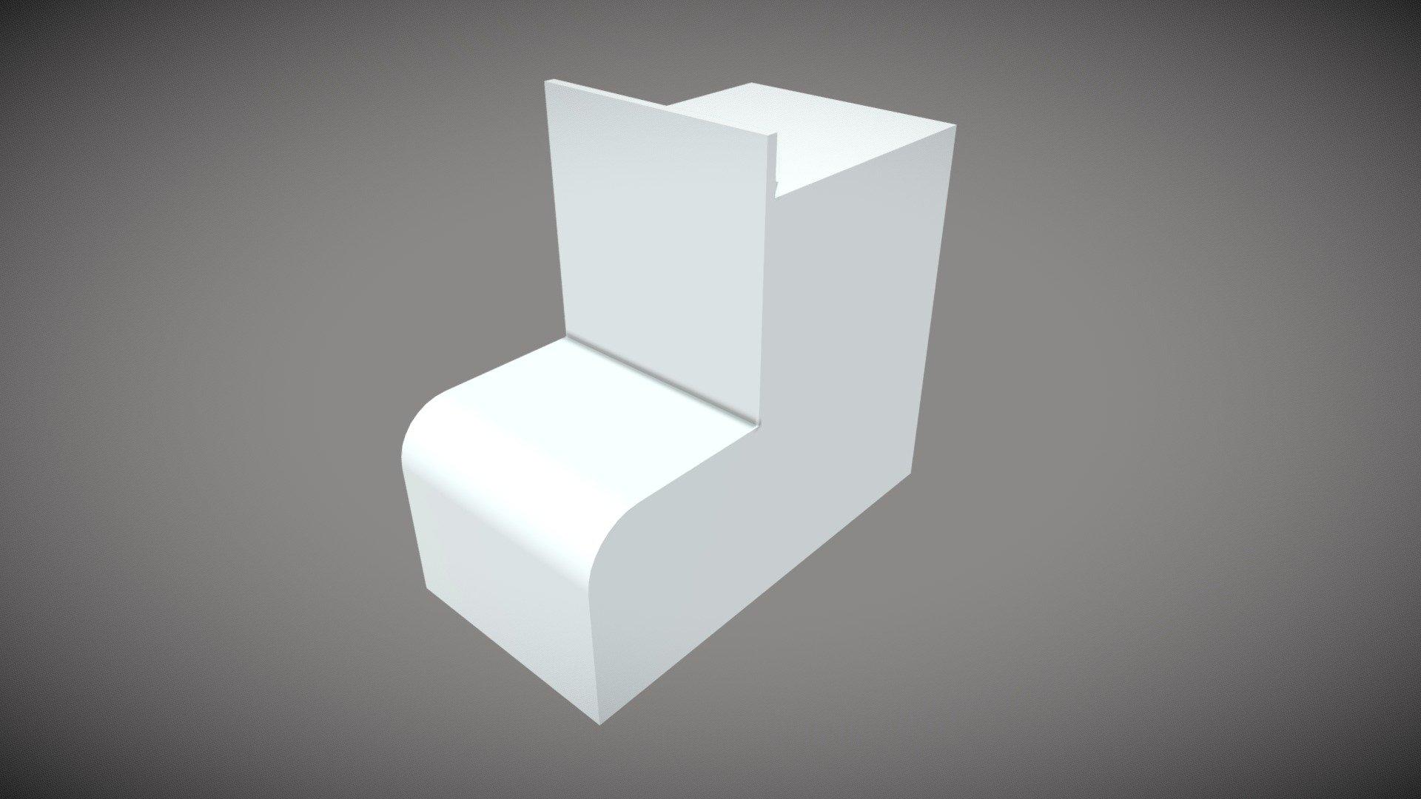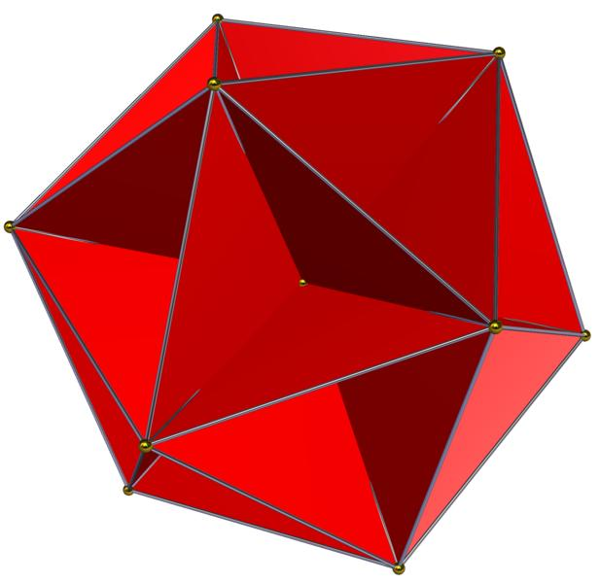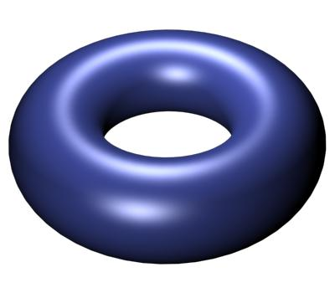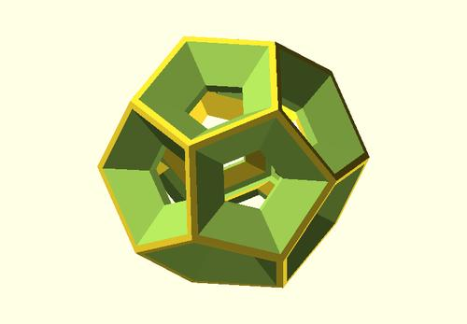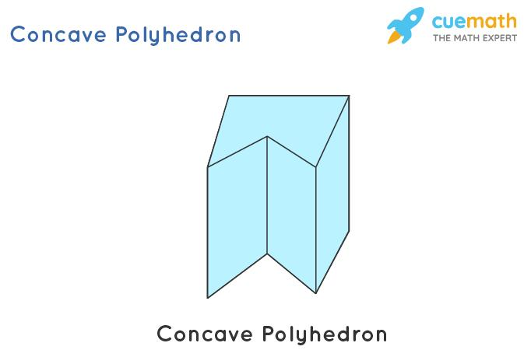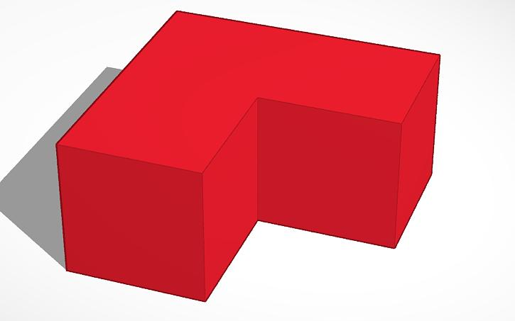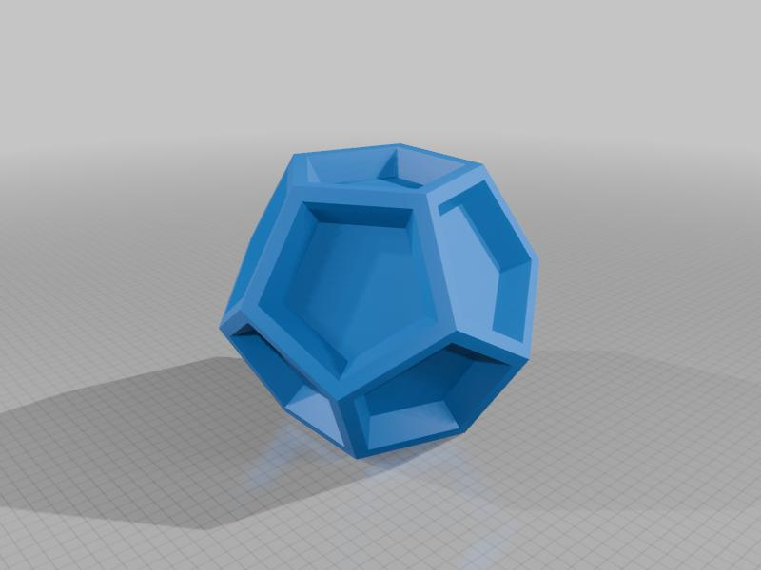

Geometric Structure
# Source: AI Source: Provided by: [Data Path: Persons Table -> ID Column: 1, Name_En Column: Motasem Essam] -> From: [ChatGPT] on [7/25/2026]
Concave solids may have one or more of the following characteristics:
- Inward Indentations: Portions of the boundary curve or extend inward rather than outward.
- Recessed Regions: Parts of the solid are set back from the surrounding outer surfaces.
- Notches: Sections are removed from the outer shape, creating inward openings along its boundary.
- Cavities or Holes: Some concave solids contain enclosed or open spaces, depending on their construction.
- Non-Convex Cross-Sections: Certain plane sections through the solid may produce concave two-dimensional shapes.
Not every concave solid has a hole or cavity. An inward indentation alone is sufficient to make a solid concave.

Classification of Concave Solids
# Source: AI Source: Provided by: [Data Path: Persons Table -> ID Column: 1, Name_En Column: Motasem Essam] -> From: [ChatGPT] on [7/25/2026]
Concave solids can be classified according to the geometry of their boundaries and the way their component parts are arranged.

Concave Polyhedra
# Source: AI Source: Provided by: [Data Path: Persons Table -> ID Column: 1, Name_En Column: Motasem Essam] -> From: [ChatGPT] on [7/25/2026]
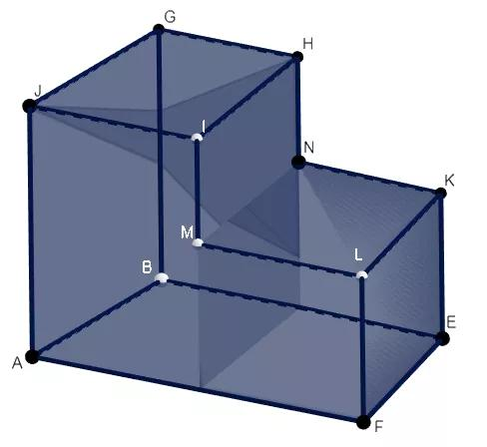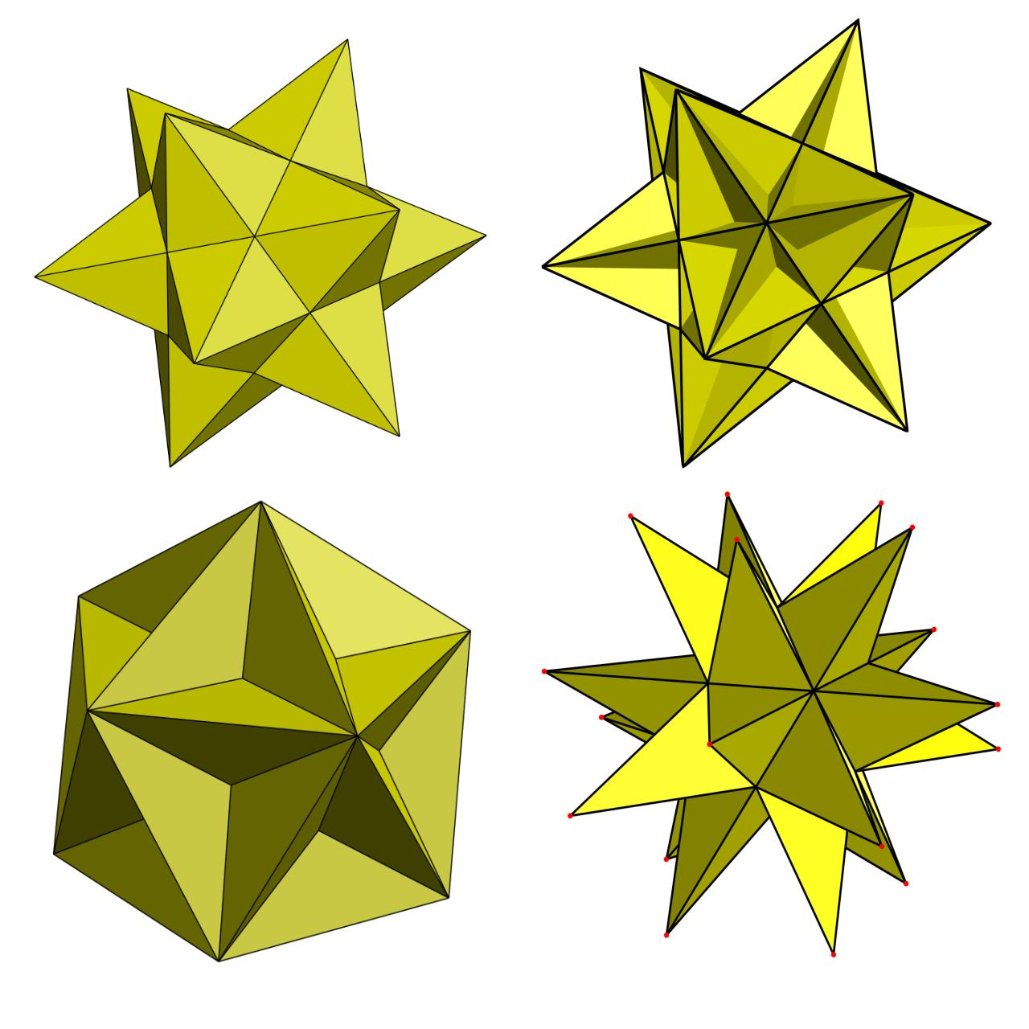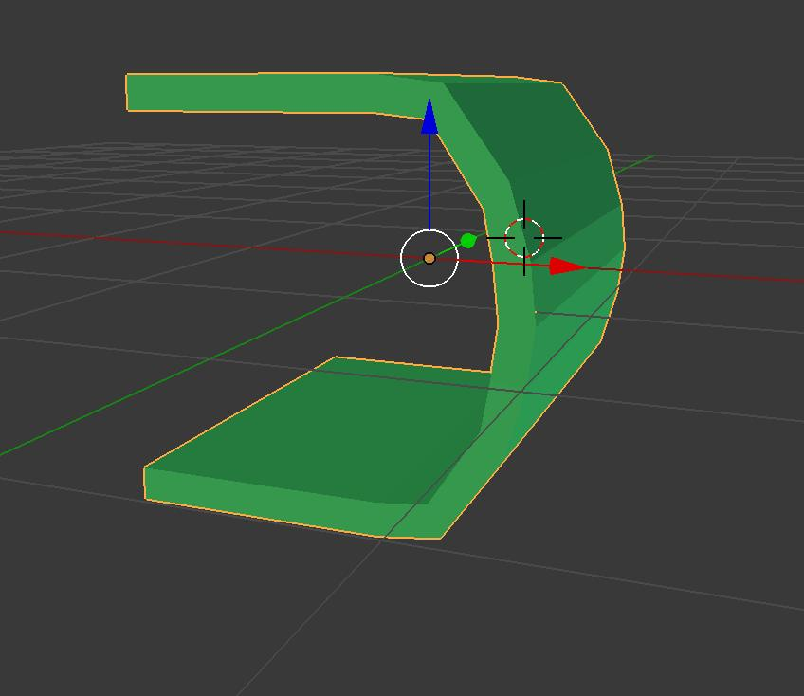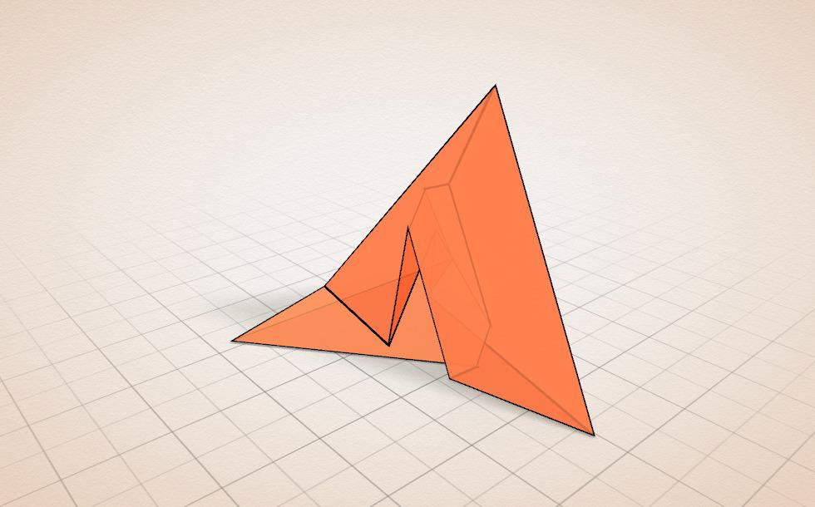
Concave polyhedra are polyhedra with polygonal faces and at least one inward indentation or non-convex region.
Main types include:
- Simple Concave Polyhedra: Polyhedra with inward indentations but without necessarily having self-intersecting faces.
- Star Polyhedra: Non-convex polyhedra whose faces or overall arrangements involve star polygons or intersecting geometric elements.
- Concave Irregular Polyhedra: Polyhedra with non-regular faces or vertices and an inwardly indented structure.
- Non-Convex Uniform Polyhedra: Uniform polyhedra that are non-convex, including several star and quasiregular forms.
Examples include the Kepler–Poinsot polyhedra and other non-convex uniform polyhedra.

Concave Curved Solids
# Source: AI Source: Provided by: [Data Path: Persons Table -> ID Column: 1, Name_En Column: Motasem Essam] -> From: [ChatGPT] on [7/25/2026]
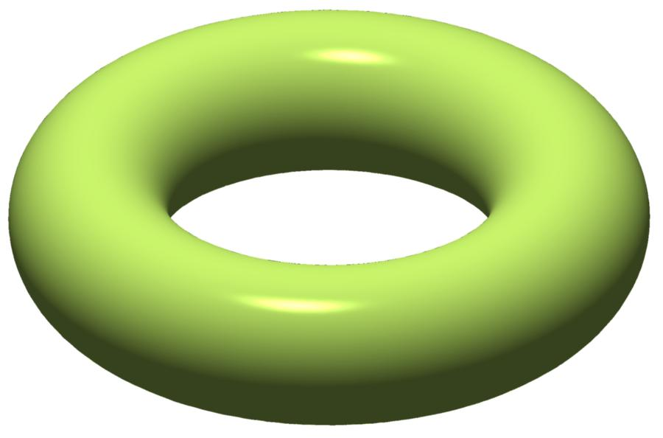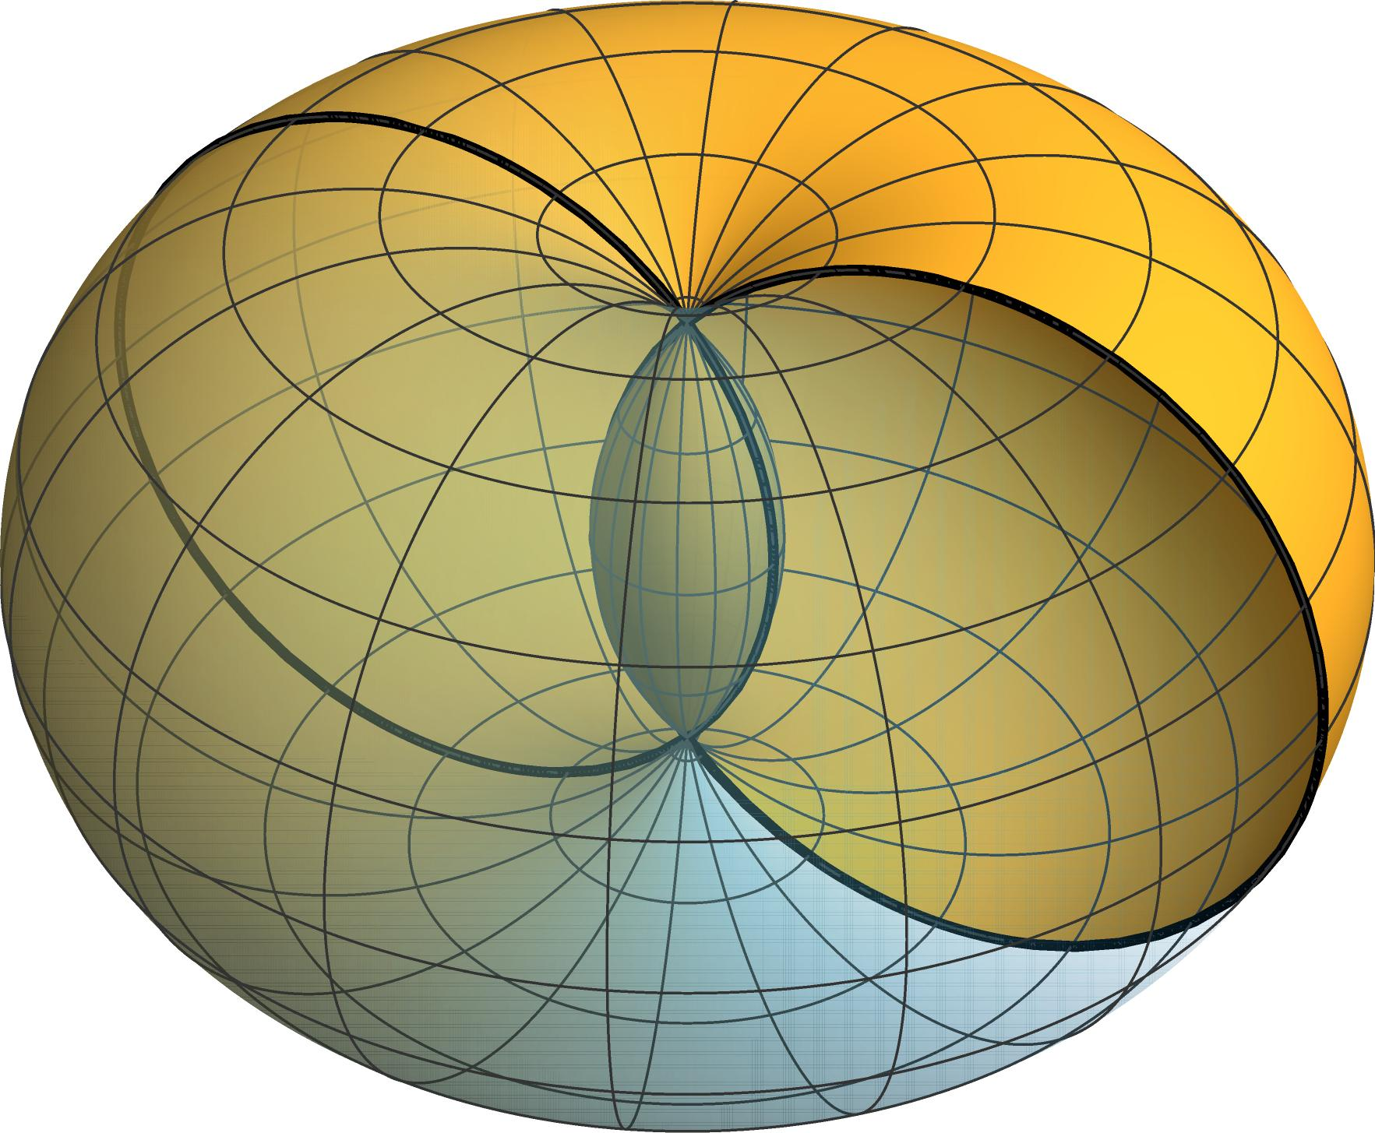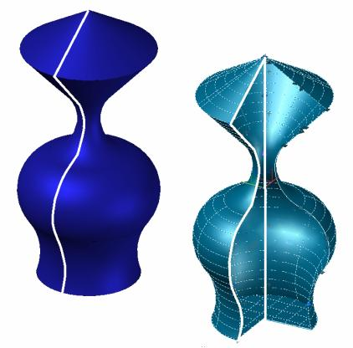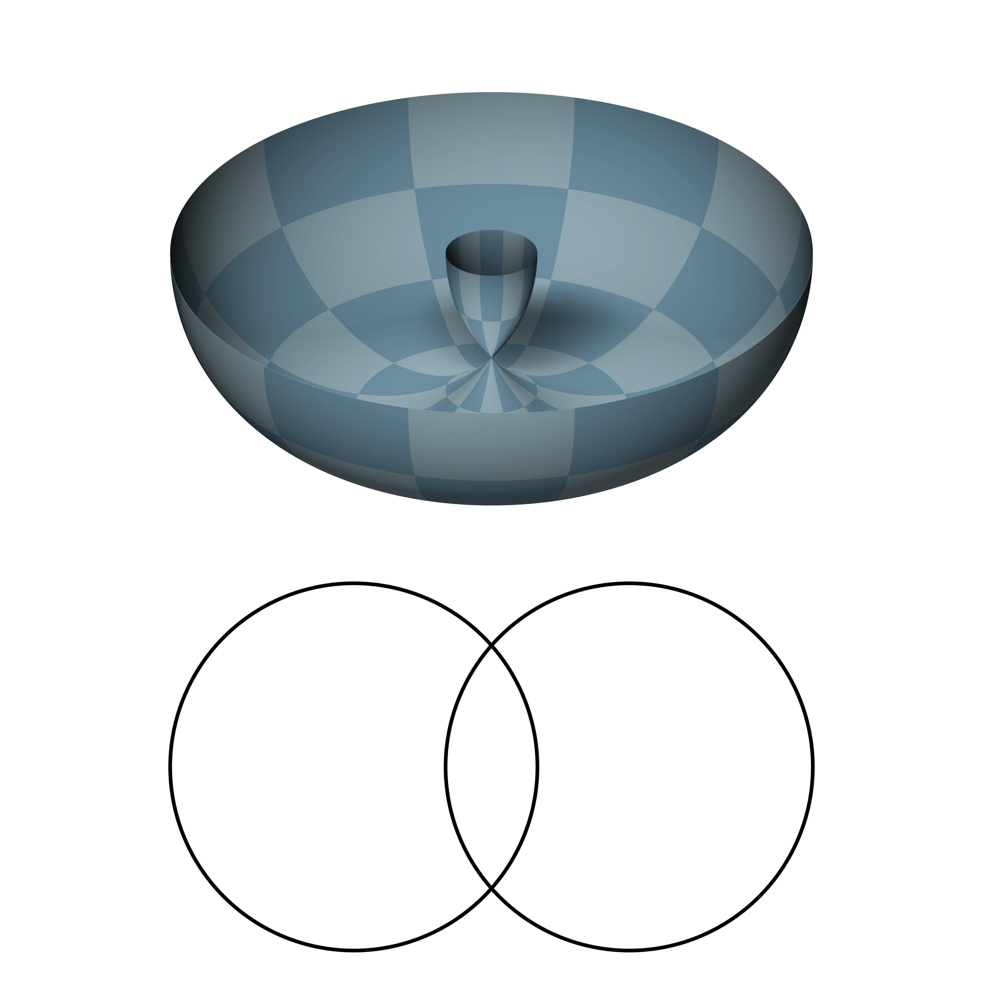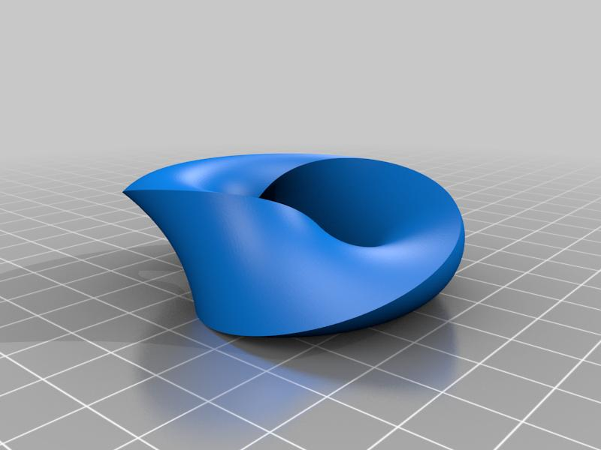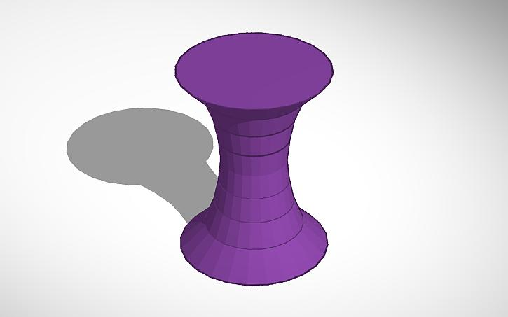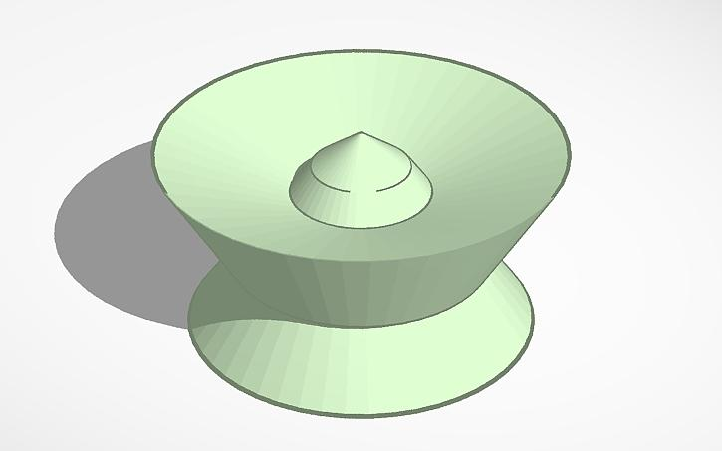
Concave curved solids are non-polyhedral solids whose boundaries include curved surfaces and whose overall solid regions are non-convex.
Examples include:
- Solid Torus: A ring-shaped solid with a central hole.
- Spindle Torus: A toroidal solid whose surface folds inward and self-intersects in its standard geometric form.
- Concave Rotational Solids: Solids generated by rotating a concave plane region around an axis.
A solid torus is a standard example: a line segment joining two points in the material can pass through its central hole and therefore leave the solid.

Concave Composite Solids
# Source: AI Source: Provided by: [Data Path: Persons Table -> ID Column: 1, Name_En Column: Motasem Essam] -> From: [ChatGPT] on [7/25/2026]
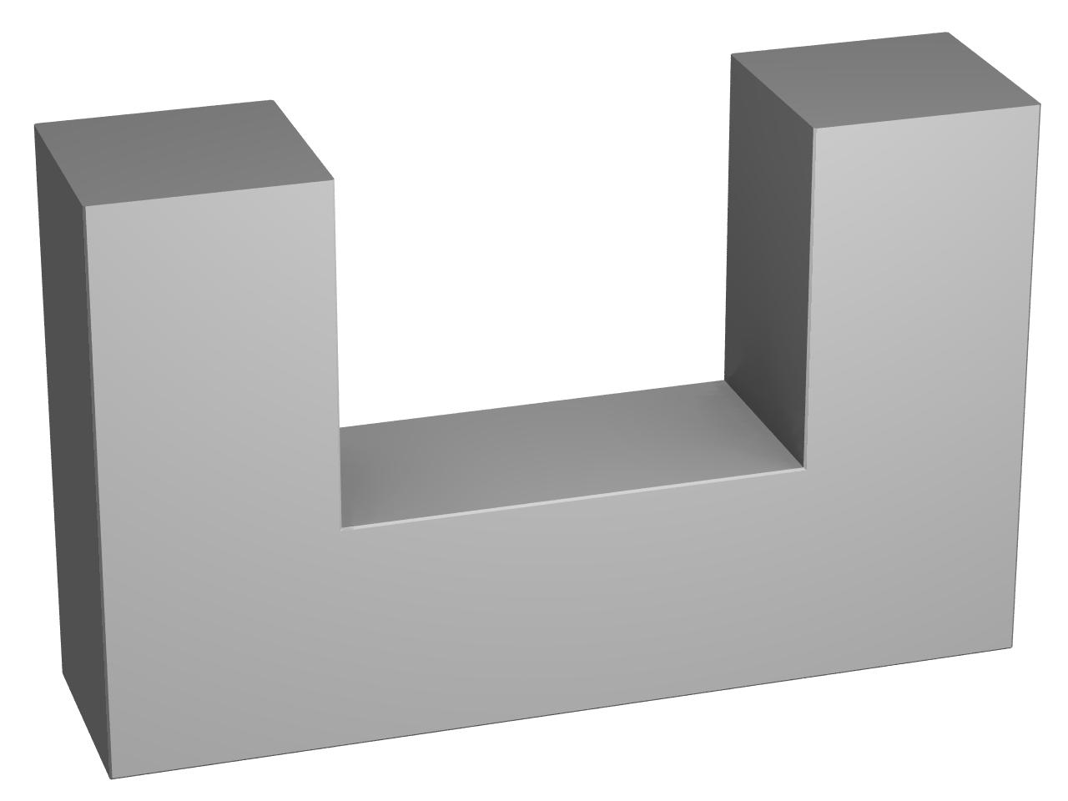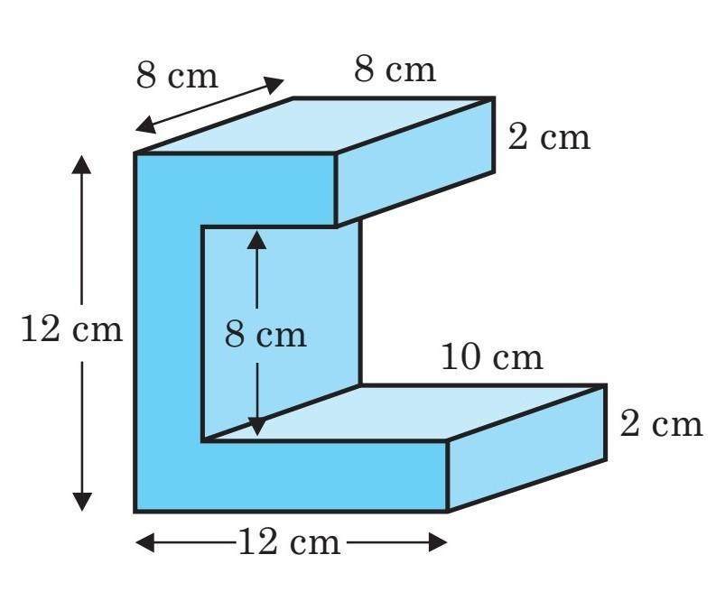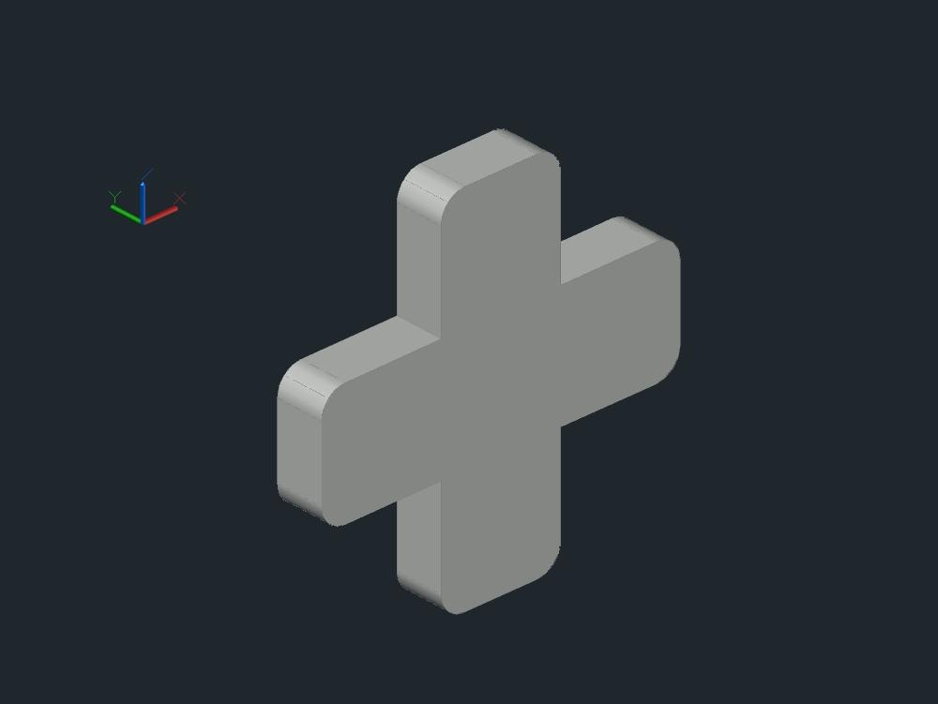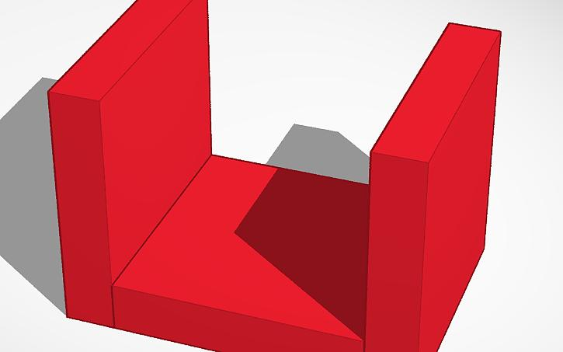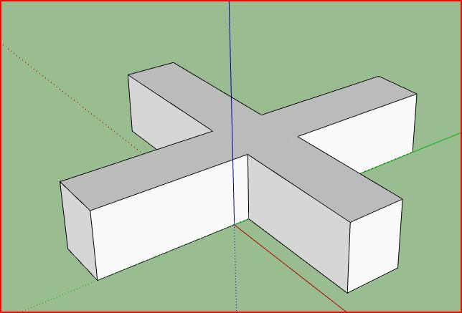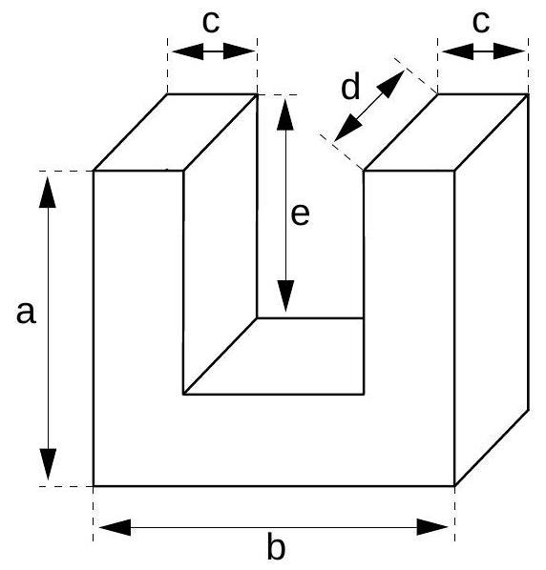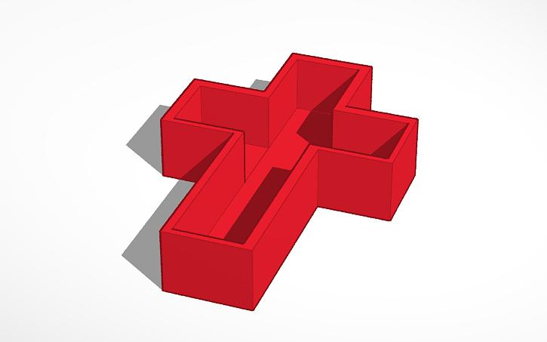
Concave composite solids are solids formed by combining two or more simpler solids in an arrangement that produces a non-convex overall shape.
Examples include:
- L-Shaped Composite Solids: Formed by joining solid components in an L-shaped arrangement.
- U-Shaped Composite Solids: Formed by arranging components around an open central region.
- Cross-Shaped Composite Solids: Formed by joining components in intersecting directions.
- Notched Composite Solids: Solids with one or more sections removed, producing inward recesses.
- Irregular Composite Solids: Combinations of components arranged to create irregular inward indentations.
The important condition is that the resulting solid must be non-convex. Combining convex solids does not automatically produce a concave solid; the final arrangement determines its convexity.

Mathematical Properties
# Source: AI Source: Provided by: [Data Path: Persons Table -> ID Column: 1, Name_En Column: Motasem Essam] -> From: [ChatGPT] on [7/25/2026]
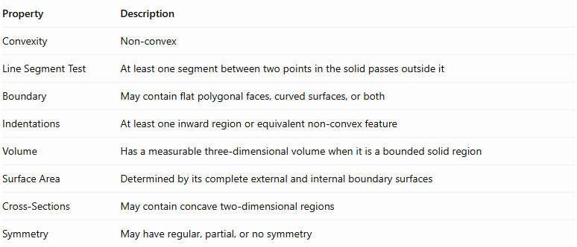
Property | Description
Convexity | Non-convex
Line Segment Test | At least one segment between two points in the solid passes outside it
Boundary | May contain flat polygonal faces, curved surfaces, or both
Indentations | At least one inward region or equivalent non-convex feature
Volume | Has a measurable three-dimensional volume when it is a bounded solid region
Surface Area | Determined by its complete external and internal boundary surfaces
Cross-Sections | May contain concave two-dimensional regions
Symmetry | May have regular, partial, or no symmetry

Mathematical Representation
# Source: AI Source: Provided by: [Data Path: Persons Table -> ID Column: 1, Name_En Column: Motasem Essam] -> From: [ChatGPT] on [7/25/2026]
Let $S$ represent a solid in three-dimensional space.
A solid is concave if there exist points $P,Q∈S$ and a value $t∈(0,1)$ such that:
$$(1-t)P+tQ∉S$$
This means that the entire line segment connecting $P$ and $Q$ is not contained within the solid.

Convex Hull
# Source: AI Source: Provided by: [Data Path: Persons Table -> ID Column: 1, Name_En Column: Motasem Essam] -> From: [ChatGPT] on [7/25/2026]
The convex hull of a concave solid is the smallest convex set that contains the entire solid.
$$Conv(S)$$
The convex hull fills in the indentations and gaps that prevent the original solid from being convex.

Comparison with Convex Solids
# Source: AI Source: Provided by: [Data Path: Persons Table -> ID Column: 1, Name_En Column: Motasem Essam] -> From: [ChatGPT] on [7/25/2026]
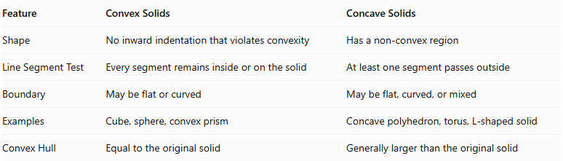
Feature | Convex Solids | Concave Solids
Shape | No inward indentation that violates convexity | Has a non-convex region
Line Segment Test | Every segment remains inside or on the solid | At least one segment passes outside
Boundary | May be flat or curved | May be flat, curved, or mixed
Examples | Cube, sphere, convex prism | Concave polyhedron, torus, L-shaped solid
Convex Hull | Equal to the original solid | Generally larger than the original solid

Main Classification
# Source: AI Source: Provided by: [Data Path: Persons Table -> ID Column: 1, Name_En Column: Motasem Essam] -> From: [ChatGPT] on [7/25/2026]
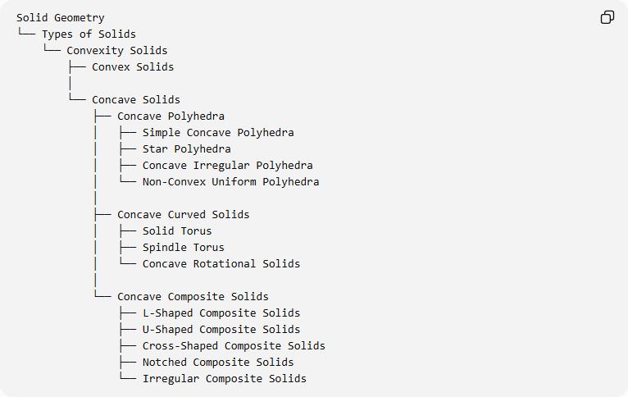
Solid Geometry
└── Types of Solids
└── Convexity Solids
├── Convex Solids
│
└── Concave Solids
├── Concave Polyhedra
│ ├── Simple Concave Polyhedra
│ ├── Star Polyhedra
│ ├── Concave Irregular Polyhedra
│ └── Non-Convex Uniform Polyhedra
│
├── Concave Curved Solids
│ ├── Solid Torus
│ ├── Spindle Torus
│ └── Concave Rotational Solids
│
└── Concave Composite Solids
├── L-Shaped Composite Solids
├── U-Shaped Composite Solids
├── Cross-Shaped Composite Solids
├── Notched Composite Solids
└── Irregular Composite Solids

Important Distinctions
# Source: AI Source: Provided by: [Data Path: Persons Table -> ID Column: 1, Name_En Column: Motasem Essam] -> From: [ChatGPT] on [7/25/2026]
- Concave Polyhedra vs. Star Polyhedra: A simple concave polyhedron has inward indentations, while a star polyhedron may have self-intersecting faces or a star-shaped arrangement. These are related but not identical categories.
- Torus vs. Spindle Torus: A ring torus is a well-defined solid with a central hole. A spindle torus is usually described as a self-intersecting surface of revolution, so its enclosed solid region requires a precise convention.
- Concave vs. Hollow: A hollow object is not automatically a concave solid. Its material region and whether it has thickness must be specified.
- Composite Solids: Their classification depends on the final combined shape, not simply on the shapes of their individual components.

Key Points
# Source: AI Source: Provided by: [Data Path: Persons Table -> ID Column: 1, Name_En Column: Motasem Essam] -> From: [ChatGPT] on [7/25/2026]
- A concave solid is a three-dimensional non-convex geometric region.
- It fails the line-segment test for convexity.
- Concave solids can have polygonal boundaries, curved boundaries, or combinations of both.
- They can be classified into concave polyhedra, concave curved solids, and concave composite solids.
- Star polyhedra and toroidal solids are important examples.
- A concave solid may have one or more inward indentations without necessarily containing a hole.

Conclusion
# Source: AI Source: Provided by: [Data Path: Persons Table -> ID Column: 1, Name_En Column: Motasem Essam] -> From: [ChatGPT] on [7/25/2026]
Concave Solids are an important classification of three-dimensional geometric solids characterized by non-convexity. They include concave polyhedra, concave curved solids, and concave composite solids. Their defining property is that at least one line segment connecting two points within the solid extends outside the solid.

